Installation Guide for MPAi Version 4.00

The following will walk you through the installation and initial running of MPAi 4.00

System Requirements:

* + Windows 7, 8.1, 10
  + At Least 1Gb of Ram is required, but at least 4Gb is recommended.
  + A relatively modern processer.

Installation:

1. Determine if your machine is running 32 or 64-bit Windows.

This can be done by going to Control Panel, then into System,

Look under the System Header. For example:

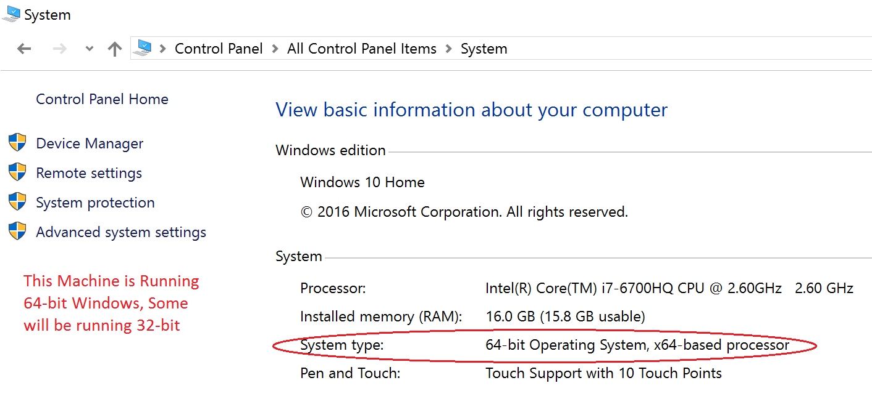

1. Download and install the latest ActivePerl:

Download ActivePerl from the following website:

<http://www.activestate.com/activeperl/downloads>

Choose “Download Active Perl 5.24.1 for Windows (x86)” If your computer is **32**-bit

Else Choose “Download Active Perl 5.24.1 for Windows (64-bit, x64)” if your computer is **64**-bit.

Click on the Active Perl .exe installer file then follow the installer wizard prompts.

1. Download and install Microsoft SQL Server 2014 Express:

Download **SQL Server 2014 Express** from the following website:

<https://www.microsoft.com/en-nz/download/details.aspx?id=42299>

Select English, then click the Download button.

If your computer is **32**-bit select “LocalDB 32BIT\SqlLocalDB.msi”

Else if your computer is **64**-bit select “LocalDB 64BIT\SqlLocalDB.msi”

Click next and your download should start automatically.

Click on the SqlLocalDB.msi file which was downloaded to install, then follow the installation wizard prompts.

1. Download the MPAi Installer files:

Double click on **Setup.bat**, (Not Setup.exe)

Follow instructions.

You will see the loading screen,

Then an installation wizard will start.

If installation was successful a shortcut should have been created on your desktop,

Double click MPAi4.exe to Run the program. MPAi4.exe must be run as Administrator currently, As some files within the MPAi4 directory need to be changed within program files (x86)

Issue Solving:

If the program has installed but an error is occurring runtime, use Ctrl-Alt-Delete to end the process,

For example:

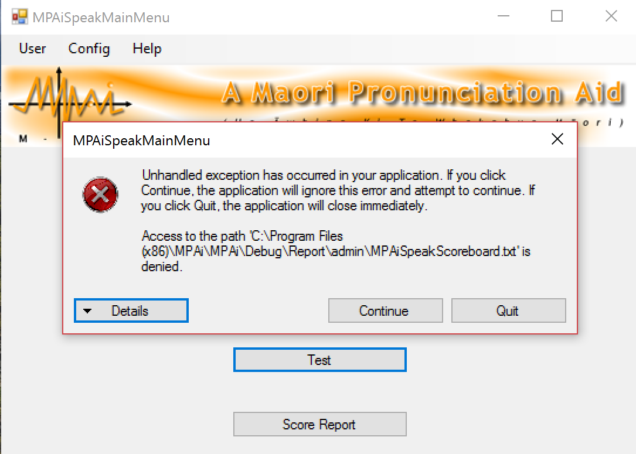

Then try running MPAi4.exe as Administrator (Right Click on MPAi4.exe and click run as administrator).

If the issue continues please check the permissions on MPAi4.exe,

Right click, click properties, under the security tab, check the permissions for the current user/ Admin.

Click Edit, then the current user then click Allow on Full control, then apply.

Repeat for Admin/Admins.

If the issue persists Please contact the Developers.